**Working With Data and Code**

**Assignment 2: Written Personal Reflection**

**Woven Weather**

**Word Count: 1100**

My coded prototype, *Woven-Weather*, aimed to visualise Sydney’s 2023 temperature data through machine embroidered hexagons. This project integrated digital fabrication, and artistic expression to transform abstract data into a tangible, aesthetic output. Throughout this reflection, I will explore key moments in my coding journey, the challenges I encountered, and the insights I gained about balancing digital code with physical fabrication.

The process of accessing temperature data through the Visual Crossing Weather API and working with JSON formats was a pivotal component of this project (Visual Crossing, n.d.; see Appendix*-*A). Handling data through an API challenged me to engage with data parsing, transforming numerical information into visual output, and preparing this data for physical representation. Fortunately, the course tutorials for JSON and python gave me a useful foundation (Hostinger, n.d.)

Mayer-Schönberger*-*and Cukier*-*(2013) define "datafication" as putting phenomena into a quantified format for analysis (p.*-*78). In my project, datafication translated Sydney’s temperature readings into embroidered forms, transforming raw numbers into a visually cohesive data narrative. I also realized the inherent subjectivity of datafication, as seen in discrepancies between temperature data from Visual Crossing and BOM, which reveals the limitations and choices involved in representing data (van Dijck, 2014).

Furthermore, using a third-party*-*API like Visual Crossing meant I had an inherent reliance on the integrity and reliability of that data. As noted by van Dijck, datafication requires trust in the independence and integrity of the organisations that own the datafication process (2014, p.*-*198). I realised how dependent my project was on external data providers and how such dependencies could significantly influence the design outcome, especially since a difference of even 0.5 degrees would completely change the colour of a hexagon. I feel this has further implications for how any data-driven project and design has to implicitly trust their source of data. This experience taught me to apply a more critical perspective when working with data sources, paying close attention to their reliability and limitations.

Using the temperature data, I employed trigonometric functions in Processing to generate and tessellate hexagons, ensuring perfect geometric alignment (Appendix B). I used a procedural programming approach, structuring the logic sequentially in Processing, which allowed me to iterate and test each stage of the hexagon generation efficiently. My choice aligns with the discussion on procedural versus object-oriented programming, highlighting the value of a linear approach for complex tasks (De*-*Silva, 2023). Specifically, learning how to code and use loops to draw and position the hexagons effectively broke down the complex tessellation process into manageable parts, which streamlined both code development and testing. Feedback from my peers exploring art or animations in Processing was invaluable as I frequently ran into errors and had to constantly change my ‘vision’ of what the blanket would look like (Appendix C).

The integration of PEmbroider and custom stitching was another significant step in my learning after I figured out how to arrange the hexagons, as using an open-source library encouraged me to extend its functionality to benefit my specific project needs. Initially, I struggled to understand Processing, a language quite different from Python, which I was more familiar with. However, relying on “online resources” and community discussions allowed me to overcome these challenges and adapt the PEmbroider library effectively (Ford,*-*2015; Appendix E). It was not enough to simply use the raw files; I had to adapt the code, experiment with different stitch types, and establish unique visual patterns for each season (Levin et al., 2020). I believe this highlights the collaborative and iterative nature of coding, where shared knowledge and resources become building blocks for individual creativity.

Initially, my ambition was to create 365 hexagons, representing daily temperatures of Sydney in 2023. However, when I began using it, I realised the physical constraints of the 4x4-inch hoop severely limited the size and complexity of my original design (Appendix*-*D). When encountering my issue, although I wanted to keep my 365 hexagon design I was recommended to adapt the project to focus on making what I could realistically achieve. Based on that feedback, I kept the core concept and used the knowledge I had developed through coding and experimentation, resulting in a more feasible yet still meaningful output of 24 hexagons, representing the monthly average and extreme temperatures (Appendix*-*E).

This realisation led me to pivot my approach, resulting in a new understanding of iterative design. Berry mentioned that code is often “reworked and rewritten*”*, reflecting its materiality as labour-intensive and requiring continuous iteration (2011, p. 39), emphasising the importance of starting with smaller prototypes to test feasibility and gradually expanding scope. If I had used this method from the beginning, I could have anticipated the challenges of physical fabrication earlier and adapted accordingly (Kuniavsky,*-*2008).

Reflecting on what happened, I realise that I was initially too focused on getting the code perfect. I spent weeks experimenting with Processing, trying different methods to assign colours to temperature, ensuring the arrangement was precise, and figuring out the logic for generating the hexagons. However, the constraints of the embroidery machine made it impossible to fulfill my original code in real life, emphasising that perfecting the digital design was not enough without understanding the physical limits of the materials involved (Kuniavsky, 2008)​.

Despite my disappointment, scaling down my project did teach me that the constraints could instead lead to more innovative and resourceful problem-solving (Appendix*-*E). After experimenting with the machine, I required a method to align different embroidered sections seamlessly without compromising the hexagons' visual integrity, so I included alignment dots to guide the manual placement of the fabric between multiple hoopings (Using*-*Alignment*-*Stitches, n.d.).

Kuniavsky (2008) discusses the importance of balancing affordances with user needs, particularly in the context of ubiquitous computing, where interactions must avoid overloading the user’s cognitive load. The alignment dots embody this concept: they are simple markers that fulfill their purpose without overwhelming the design, allowing the embroidery process to remain both functional and aesthetically cohesive. By matching “information priority with available sensory bandwidth,” they allowed me to avoid the obtrusive borders and grids that machine embroiders online often suggest and instead integrate a more refined solution that contributed to the overall user experience (Kuniavsky, 2008, p. 22).

To me the process of incorporating these alignment markers also highlighted the interdependence between digital and physical systems. The addition of alignment elements in the digital design and the added code to print them out ensured that it could be translated precisely into the physical world (Appendix*-*F). By designing the alignment as part of the embroidery process, I was learning from my previous mistake by treating it as an intrinsic part of the physical artifact rather than an afterthought (Kuniavsky, 2008)​.

Moving forward, I intend to continue exploring solutions that bridge the digital and physical realms, such as integrating refined alignment tools to enhance interaction as the current opinion shared by machine embroiders state this is a significant and unresolved problem (r/Machine*-*Embroidery, 2023). Sharing these experiences with the PEmbroider community could also assist others facing similar challenges.

Reflecting on my project in the context of datafication made me aware of how data-driven initiatives can contribute to dataism, a belief in the objective power of data to represent reality (van Dijck, 2014). However, although I initially believed this, my experience taught me that data is subjective, shaped by technological, design, and interpretive choices. Ultimately, I’ve learned that I had to use my creativity most when adapting, to physical constraints while still being artistically innovative. I intend to maintain a critical perspective on how data can shape creative outcomes, acknowledging the complex relationship between data, representation, and interpretation.

**References**

Berry, D. M. (2011). What is Code? In *The philosophy of software* (pp. 29–36). Palgrave Macmillan UK eBooks. https://doi.org/10.1057/9780230306479

Course Literature

Corporation, V. C. (n.d.). *Weather Query Builder*. Weather Data Services | Visual Crossing. Retrieved September 30, 2024, from https://www.visualcrossing.com/weather/weather-data-services/Sydney?v=api

Independent Resource

De Silva, K. (2023, June 29). OOP Concepts: Mastering Basics with Real-Life Examples for Easy Understanding. *Medium*. https://medium.com/@kalanamalshan98/oop-concepts-mastering-basics-with-real-life-examples-for-easy-understanding-part-1-da5b8fc21036

Course Literature

Eisenberg, J. D. (n.d.). *2D Transformations*. Processing. Retrieved October 6, 2024, from https://processing.org/tutorials/transform2d

Tutorial

Ford, P. (2015, June 11). *What Is Code? If You Don’t Know, You Need to Read This*. Bloomberg.com. https://www.bloomberg.com/graphics/2015-paul-ford-what-is-code/

Course Literature

Fry, B. (2007). *Processing Overview*. Processing. Retrieved September 25, 2024, from https://processing.org/tutorials/overview

Tutorial

Gelal, O. (2015a, November 27). *Ultimate Guide to the Processing Language Part I: The Fundamentals*. Toptal Engineering Blog. https://www.toptal.com/game/ultimate-guide-to-processing-the-fundamentals

Gelal, O. (2015b, December 17). *Ultimate Guide to the Processing Language Part II: Building a Simple Game*. Toptal Engineering Blog. Retrieved September 25, 2024, from https://www.toptal.com/game/ultimate-guide-to-processing-simple-game

Tutorial

HappyCoding.io, & Workman, K. (2016). *Processing Tutorials*. Happy Coding. Retrieved October 5, 2024, from https://happycoding.io/tutorials/processing/

Tutorial

HOSTINGER. (n.d.). JSON Cheat Sheet. In *Three. Two. Online*. https://cdn.hostinger.com/tutorials/pdf/JSON-Cheat-Sheet.pdf

Course Resource

Kuniavsky, M. (2010). User experience design for ubiquitous computing. *Interactions*, *15*(6), 20–22. https://doi.org/10.1145/1409040.1409045

Course Literature

Levin, G., Huang, L., Mustakos, T., & Moore, D. (2020). PEmbroider [Software]. In *GitHub*. Frank-Ratchye STUDIO for Creative Inquiry. https://github.com/CreativeInquiry/PEmbroider

Imported Library

Louis. (2016, June 19). *Tinkering in Processing - Drawing a Hexagonal Grid*. Louis Christodoulou. Retrieved October 3, 2024, from https://louisc.co.uk/?p=2554

Independent Resource

Mayer-Schönberger, V., & Cukier, K. (2013). *Big Data: A Revolution that Will Transform how We Live, Work, and Think* (Issue 9, p. 189). Houghton Mifflin Harcourt. https://doi.org/10.25009/clivajes-rcs.v0i9.2536

Course Literature

Pazos, A. (n.d.). *Processing*. Fun Programming - Creative Coding Video Tutorials. Retrieved September 25, 2024, from https://funprogramming.org/

Tutorial

Reas, C., & Fry, B. (2014). Arrays. In *Processing: A Programming Handbook for Visual Designers, Second Edition*. The MIT Press. https://processing.org/tutorials/arrays

Tutorial

Reas, C., & Fry, B. (2015). *Getting started*. Processing. Retrieved September 27, 2024, from https://processing.org/tutorials/gettingstarted

Tutorial

*r/Machine_Embroidery: HELP I bought this embroidery machine thinking I could do large embroidery patterns*. (2022). Reddit. Retrieved November 6, 2024, from https://www.reddit.com/r/Machine_Embroidery/comments/18hq4kg/help_i_bought_this_embroidery_machine_thinking_i/

Independent Resource

Shiffman, D. (n.d.). *PShape*. Processing. Retrieved September 26, 2024, from https://processing.org/tutorials/pshape

Tutorial

Shiffman, D. (2008a). *Color*. Processing. Retrieved October 1, 2024, from https://processing.org/tutorials/color

Tutorial

Shiffman, D. (2008b). *Coordinate System and Shapes*. Processing. Retrieved September 27, 2024, from https://processing.org/tutorials/coordinatesystemandshapes

Tutorial

Shiffman, D. (2008c). *Objects*. Processing. Retrieved September 30, 2024, from https://processing.org/tutorials/objects

Tutorial

Shiffman, D. (2008d). *Strings and Drawing Text*. Processing. Retrieved October 7, 2024, from https://processing.org/tutorials/text

Tutorial

Shiffman, D. (2008e). *Two-Dimensional arrays*. Processing. Retrieved October 5, 2024, from https://processing.org/tutorials/2darray

Tutorial

*Using Alignment Stitches*. (n.d.). Retrieved November 6, 2024, from https://urbanthreads.com/learn/how-to/using-alignment-stitches-machine-embroidery#

Independent Resources

Van Dijck, J. (2014). Datafication, dataism and dataveillance: Big Data between scientific paradigm and ideology. *Surveillance & Society*, *12*(2), 197–208. https://doi.org/10.24908/ss.v12i2.4776

Course Literature

**Appendix**

**Appendix A**

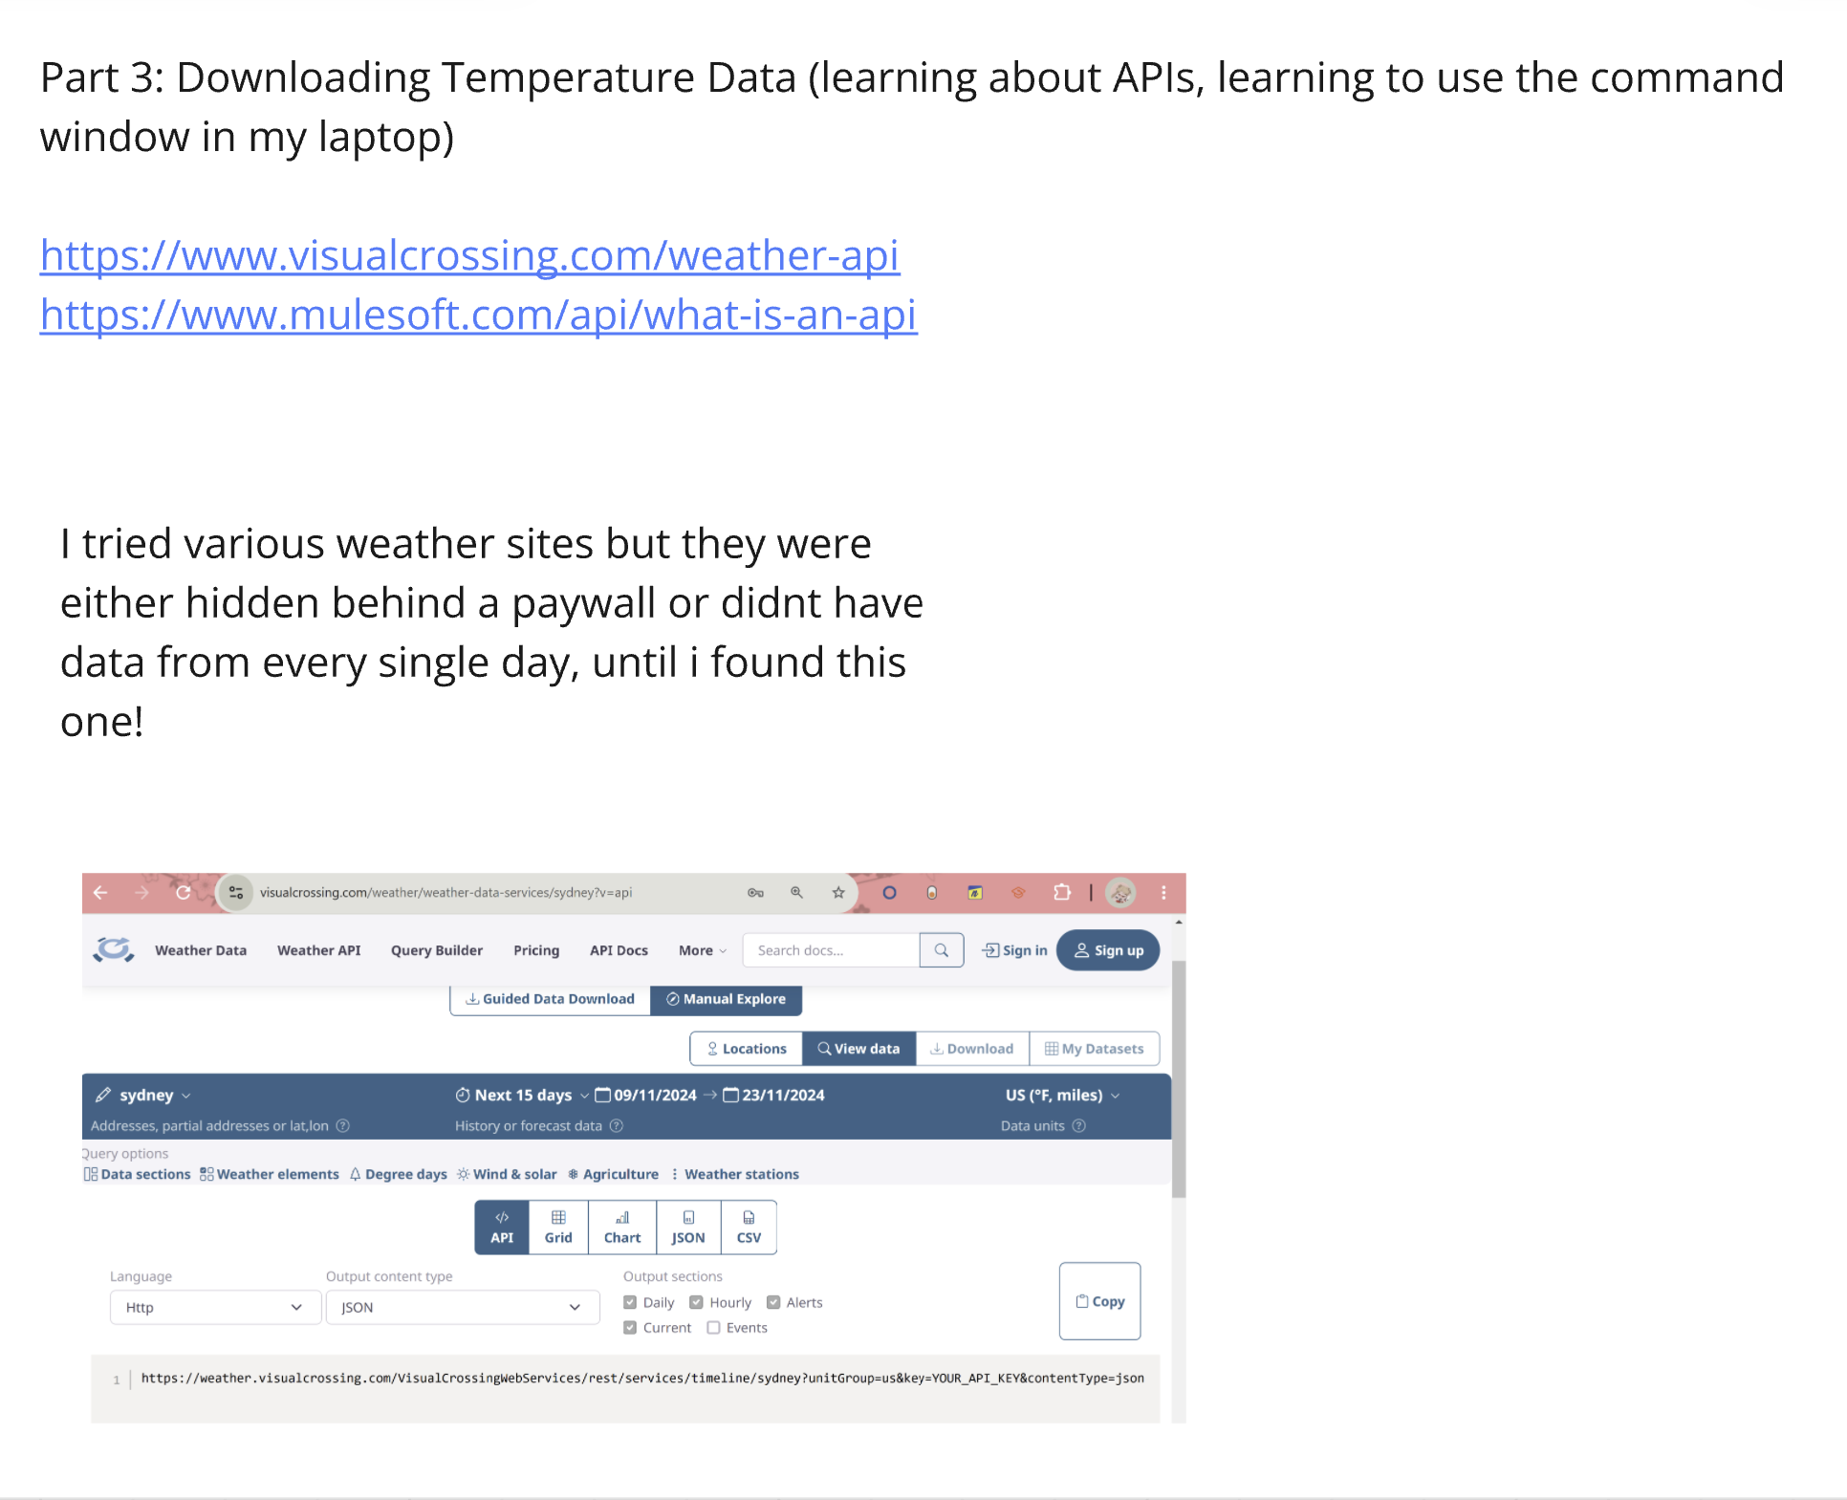

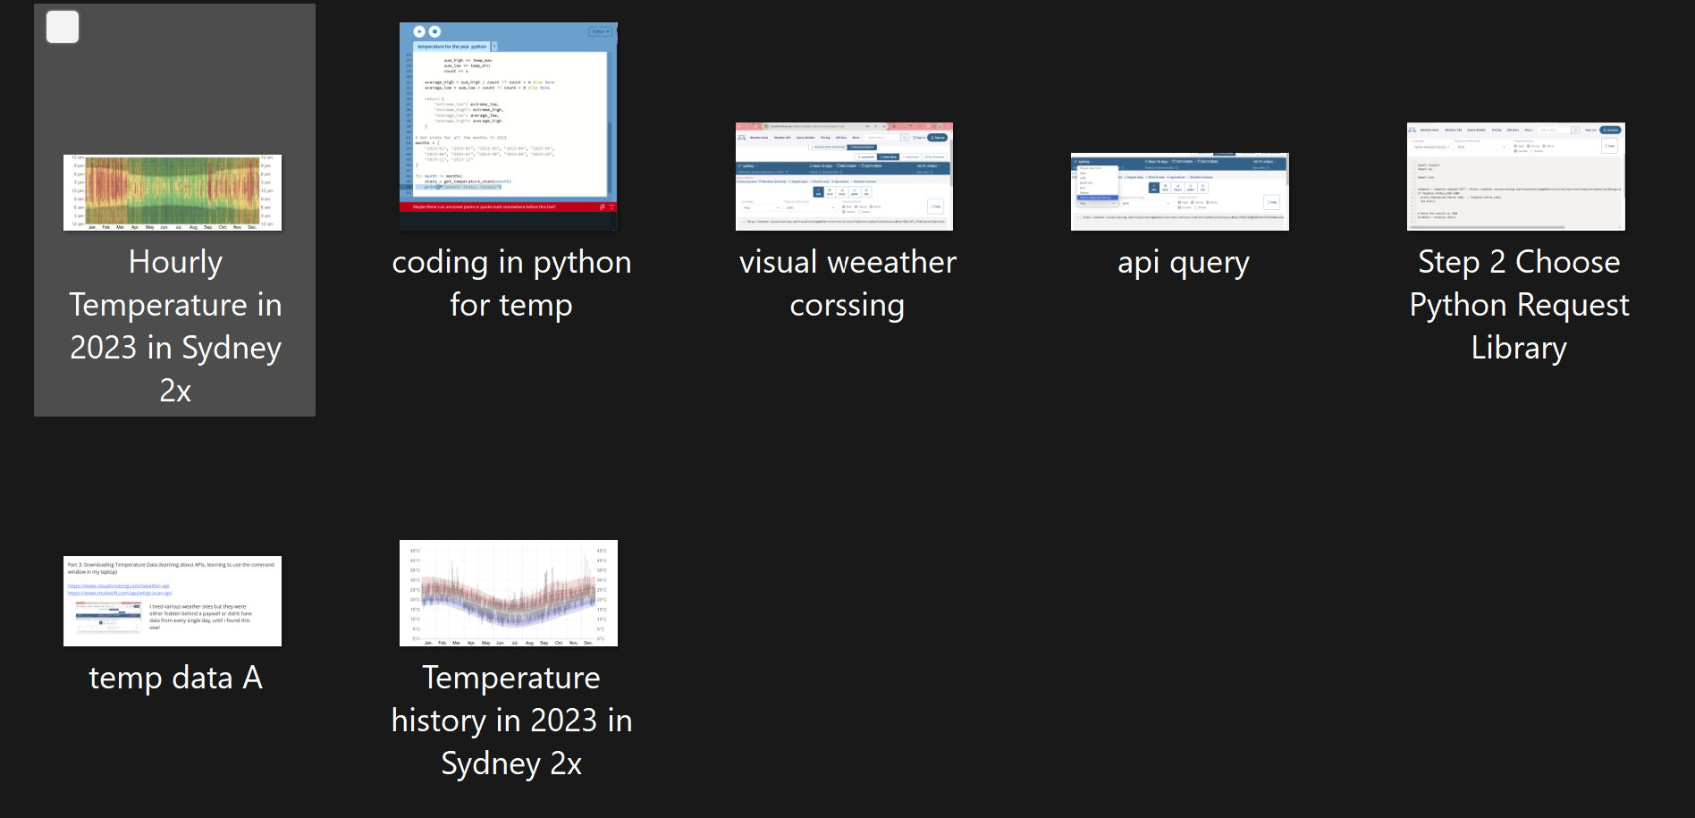

**Appendix B**

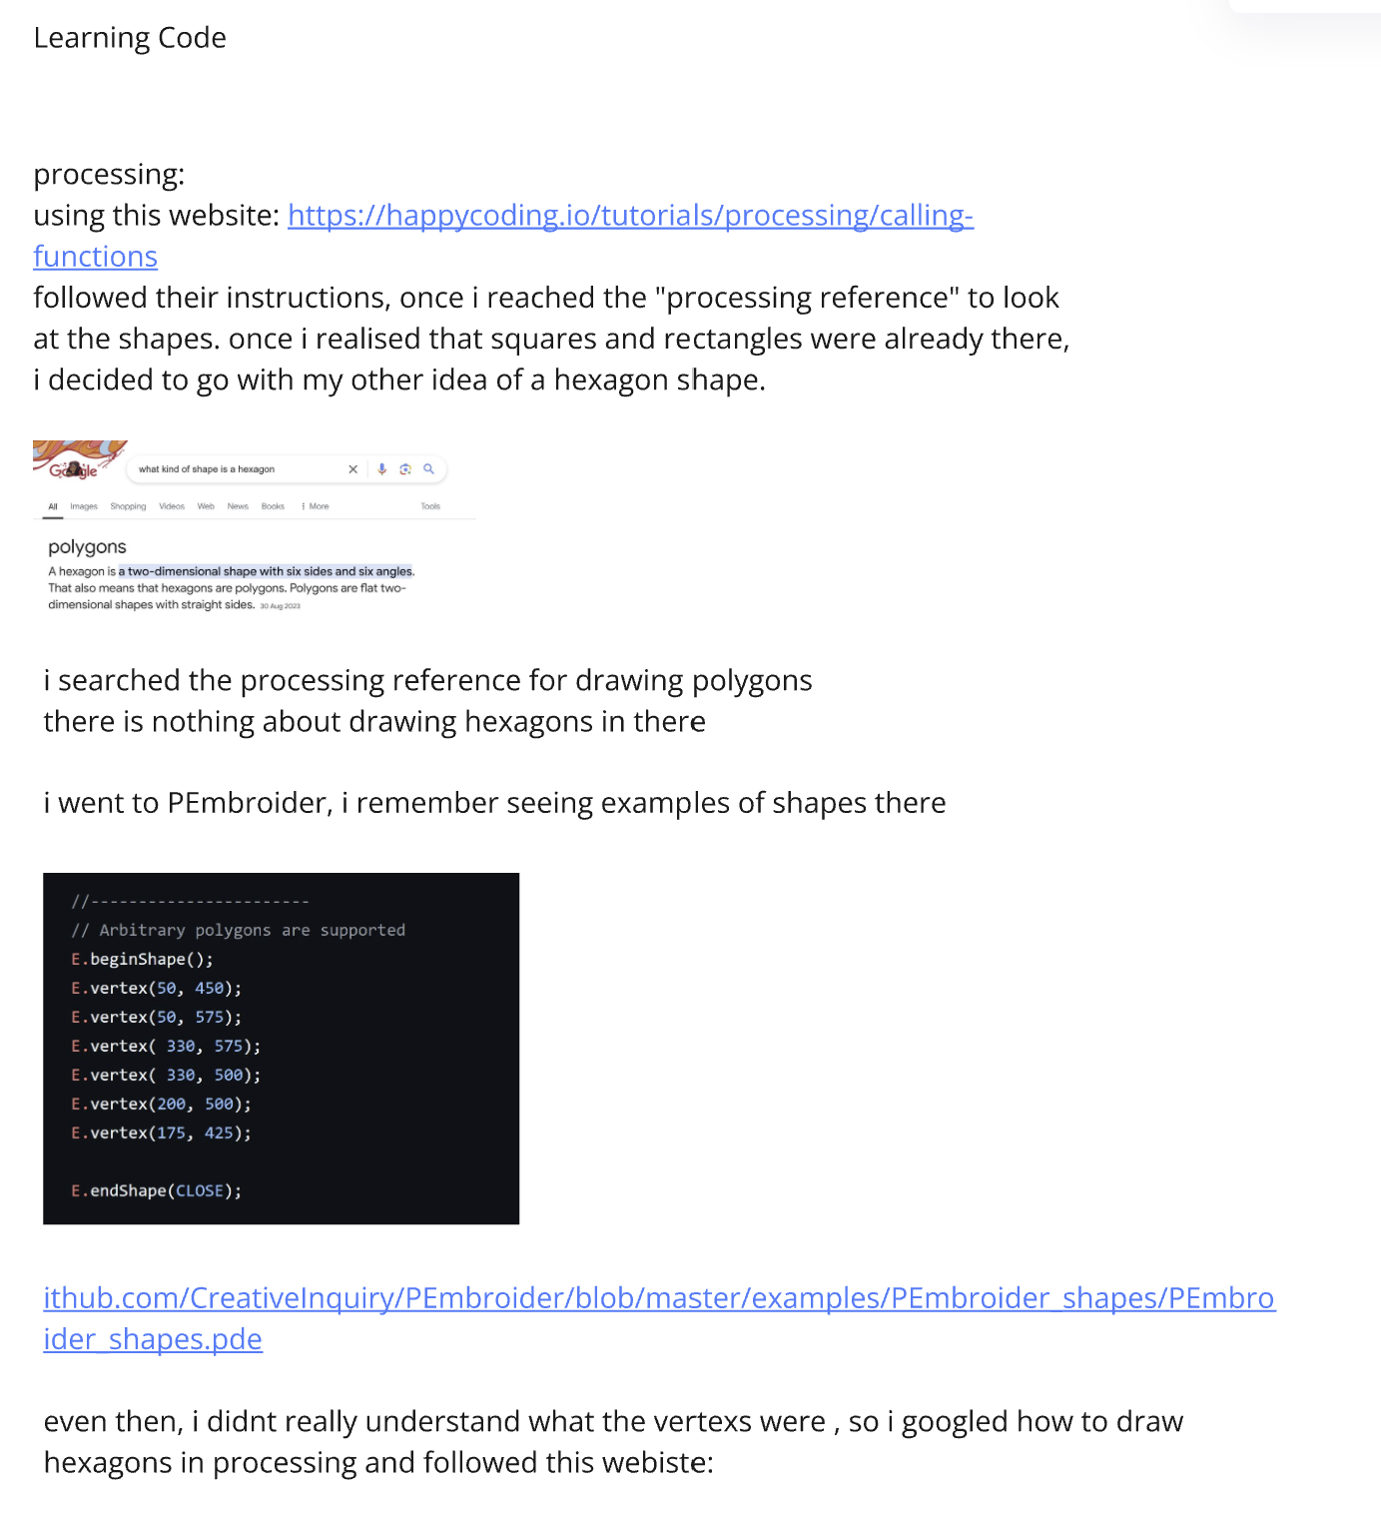

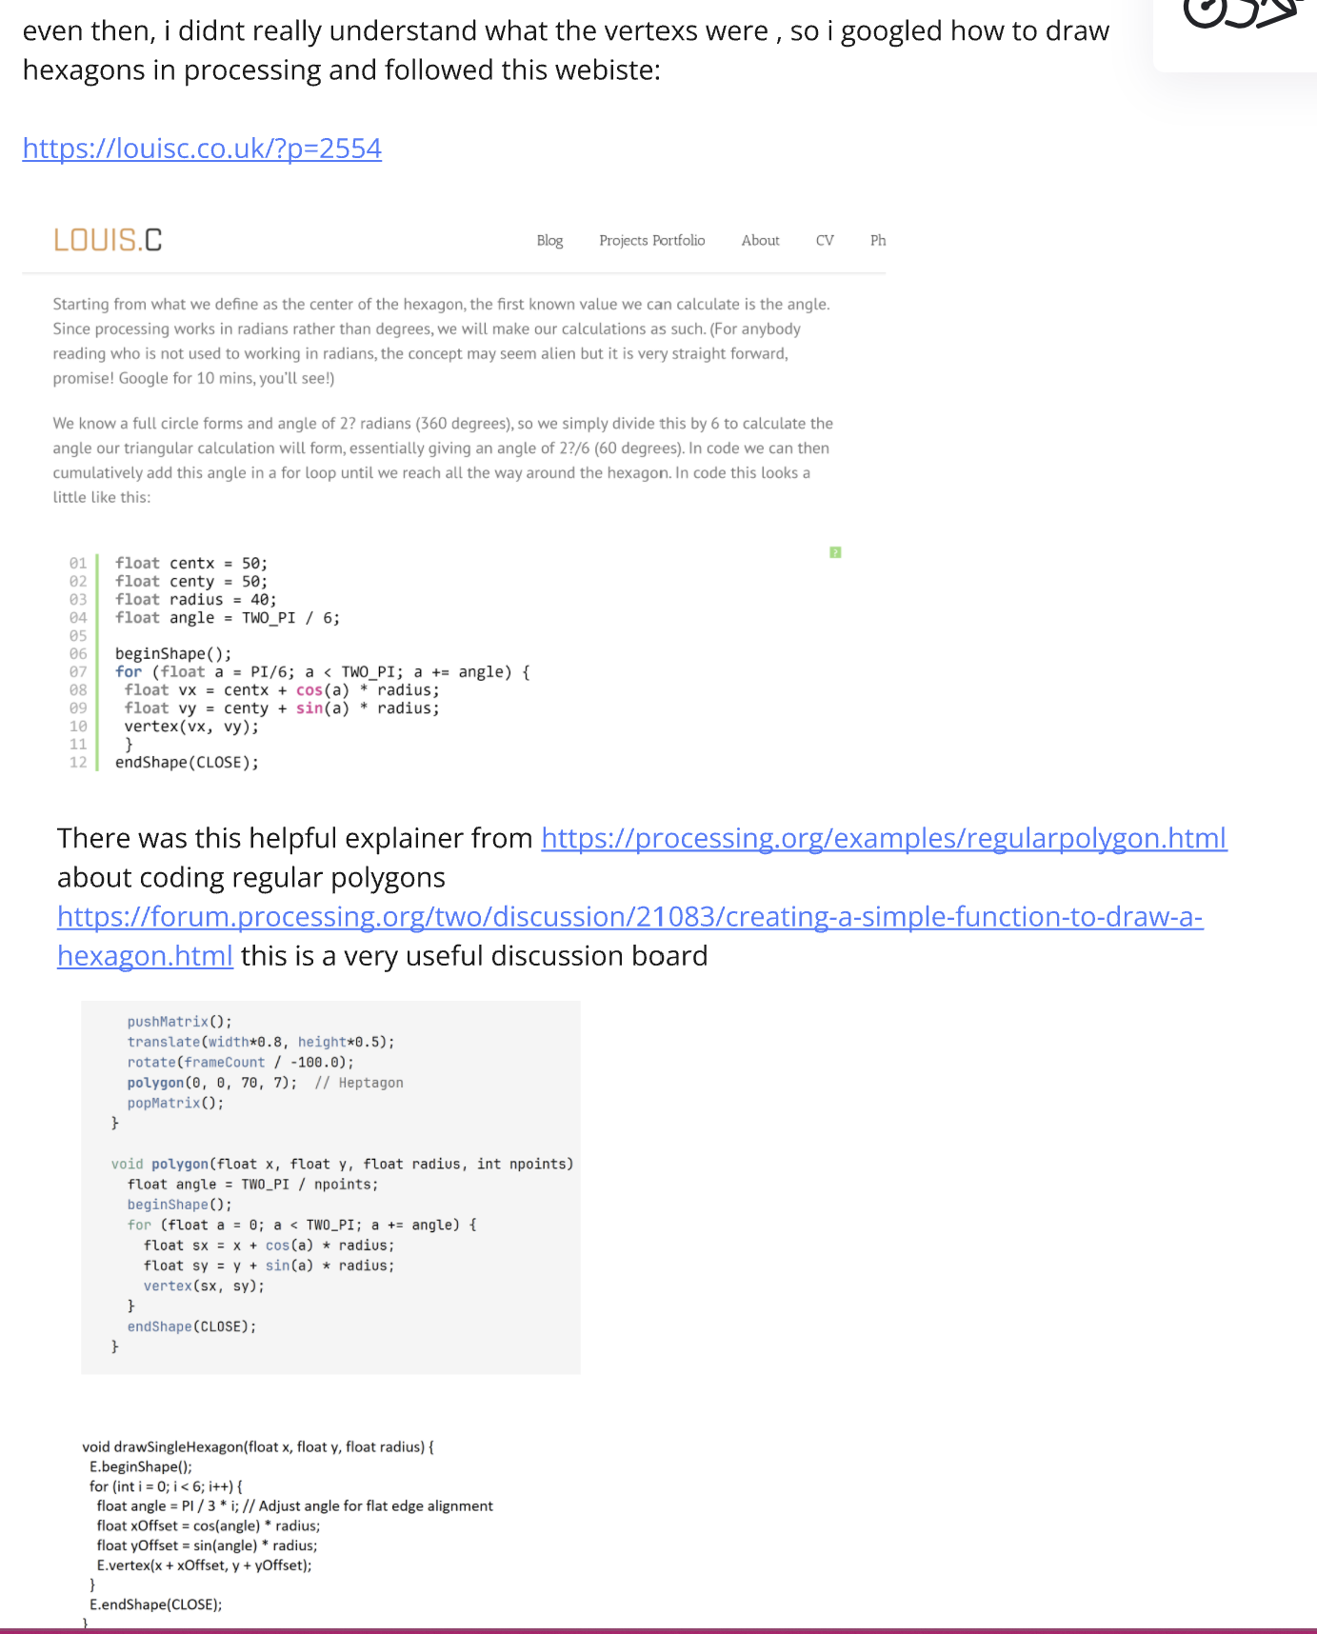

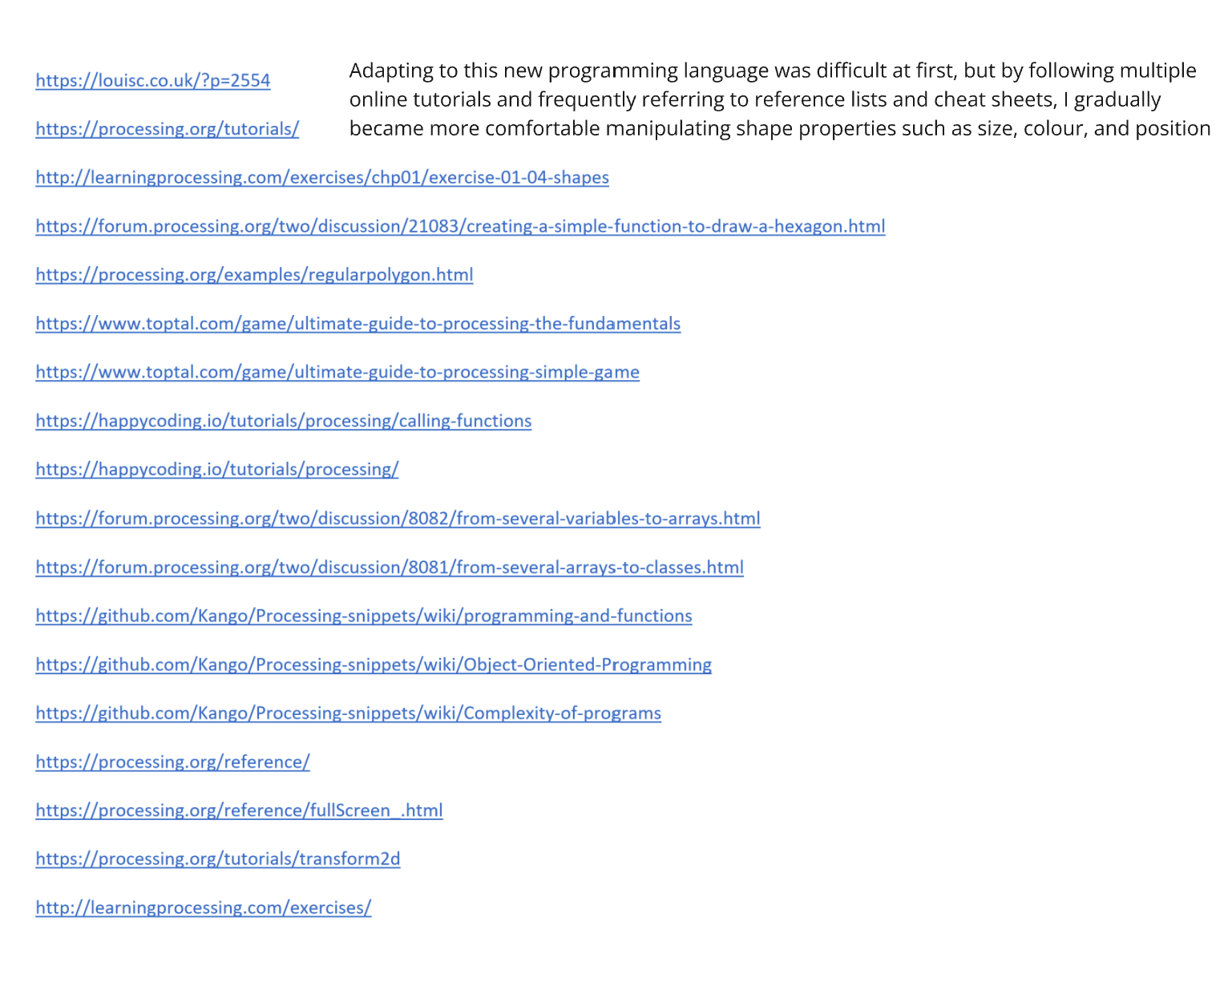

**Appendix C**

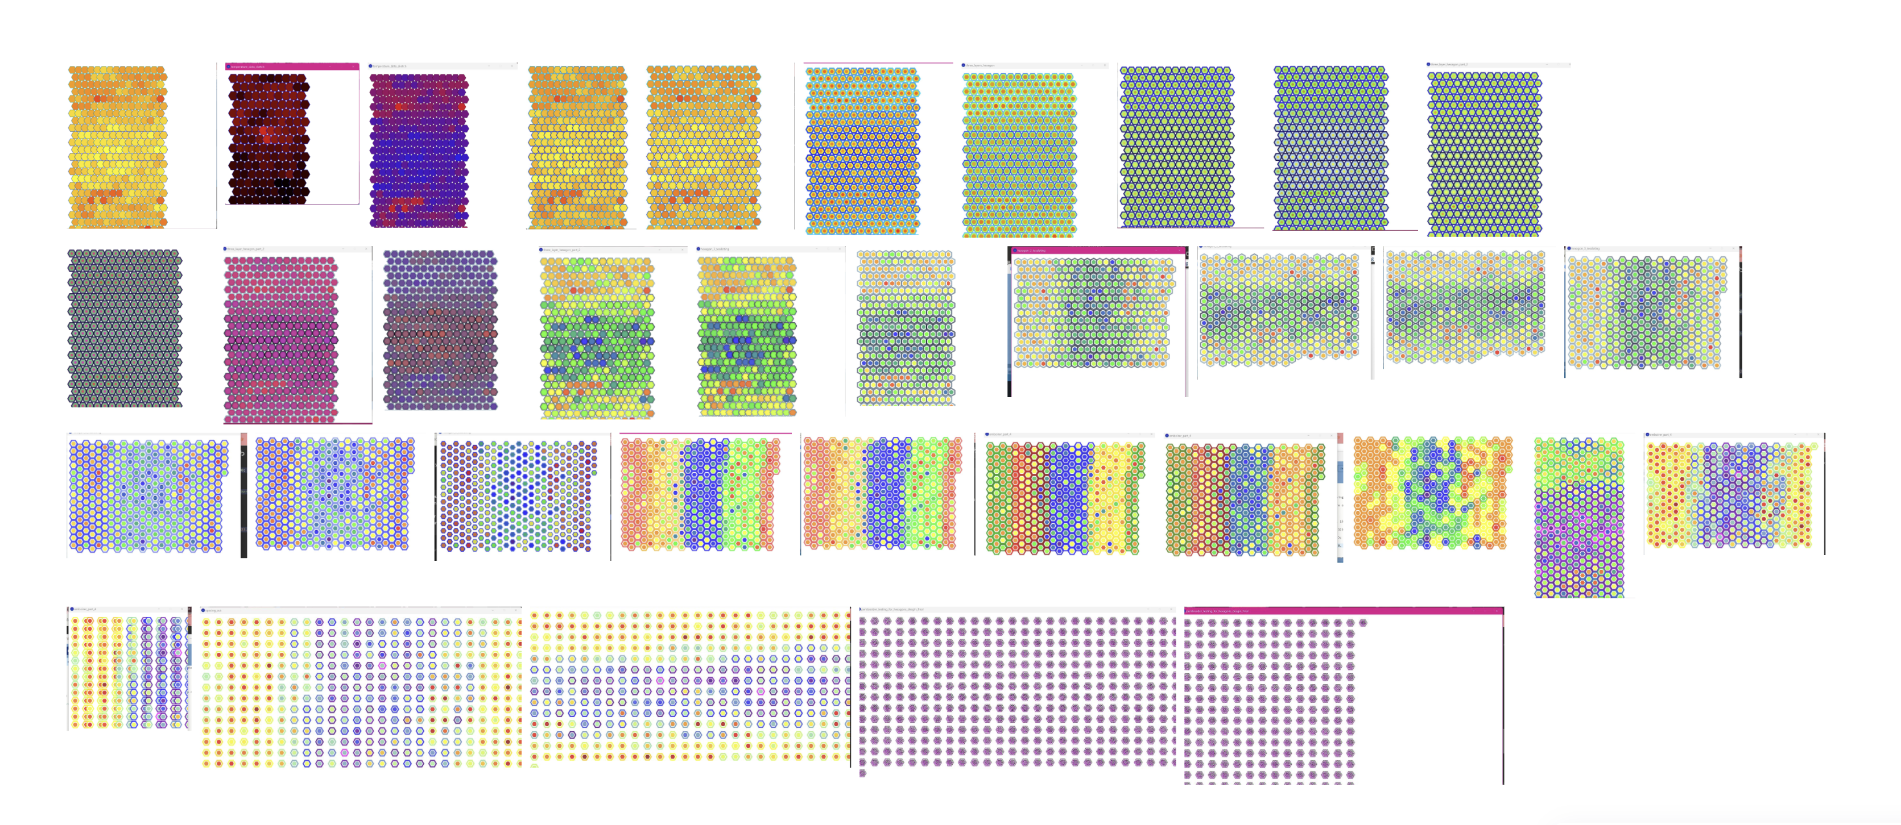

**Appendix D**

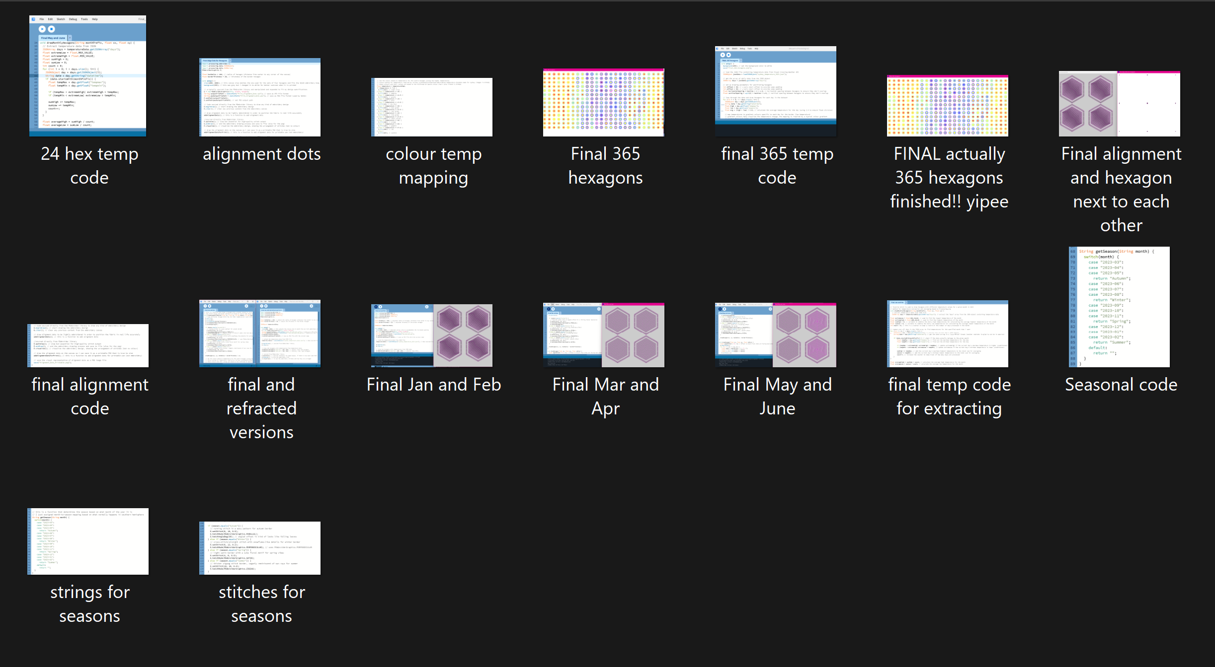

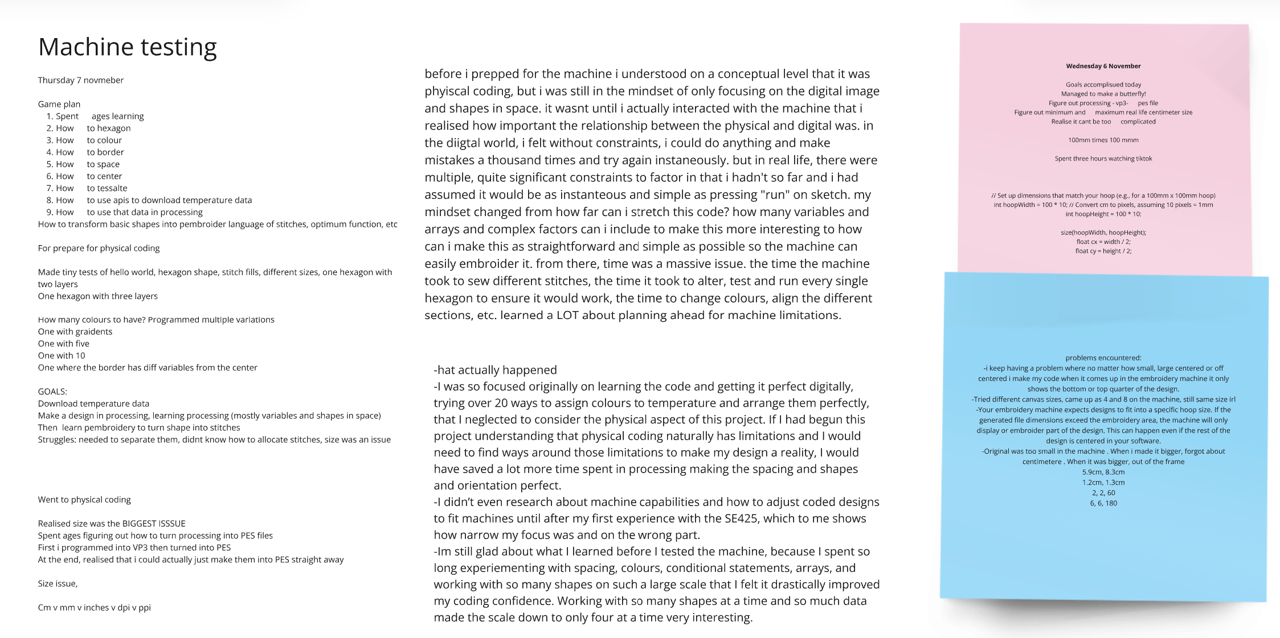

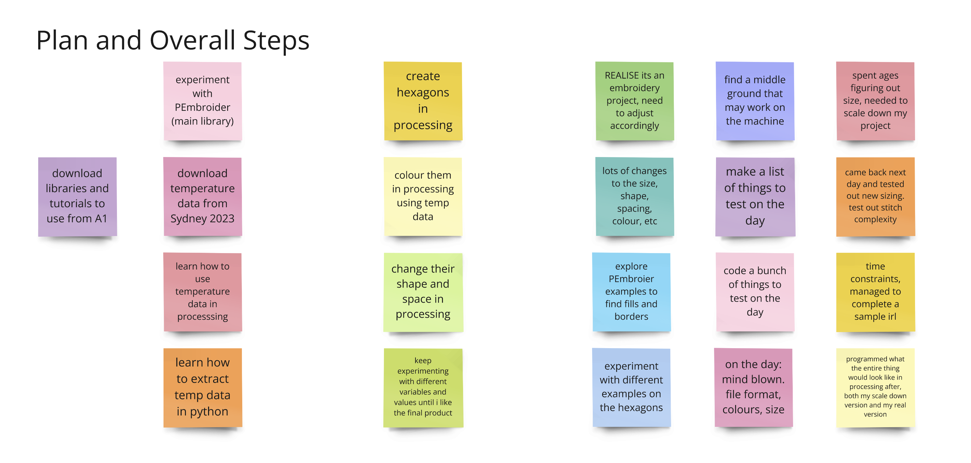

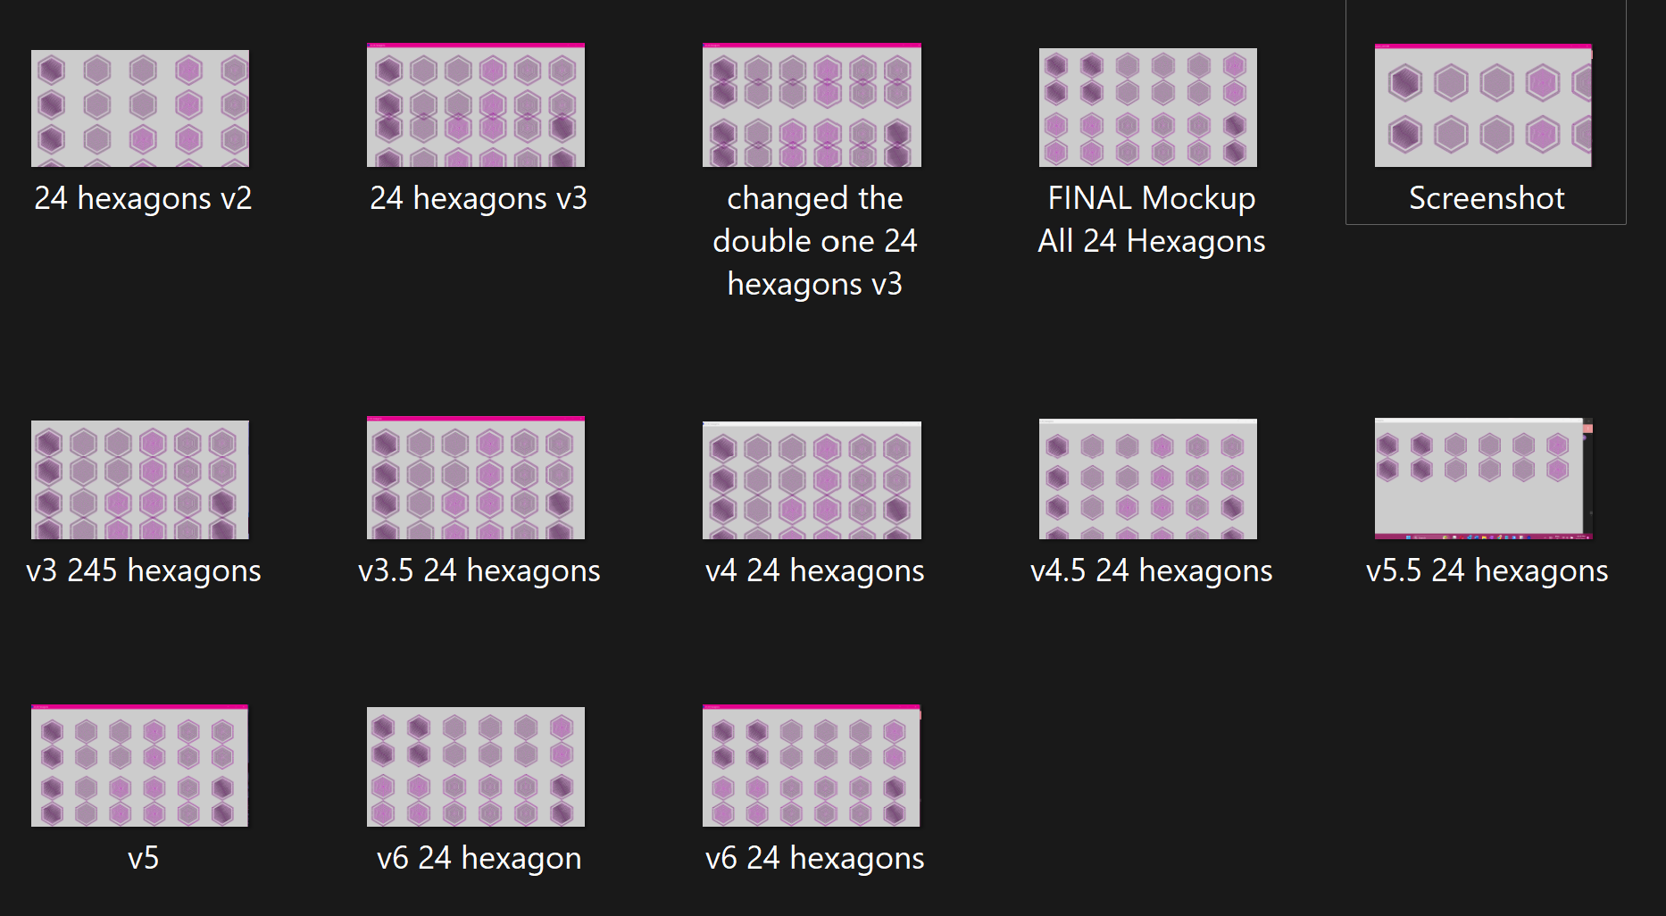

**Appendix E**

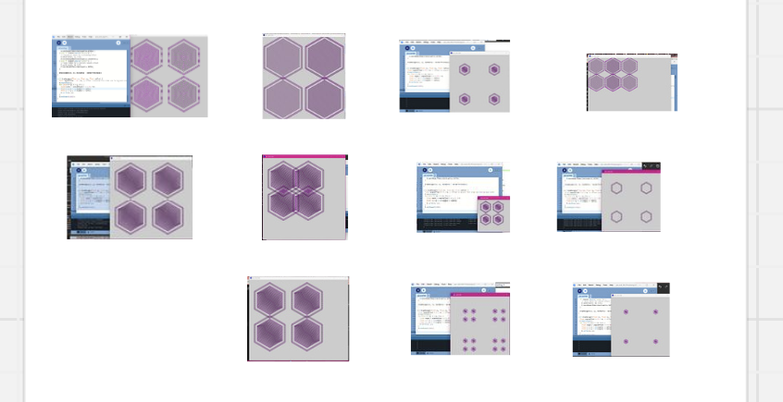

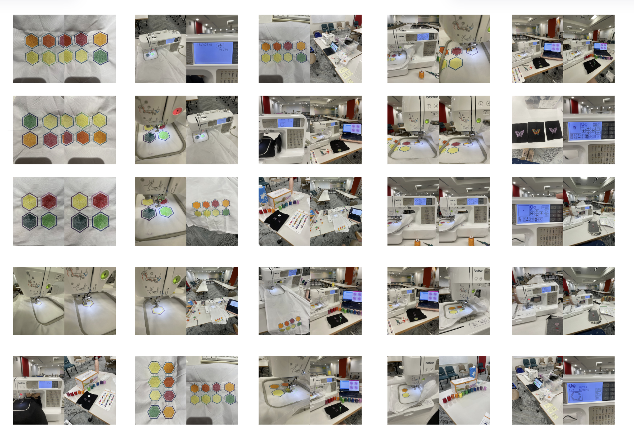

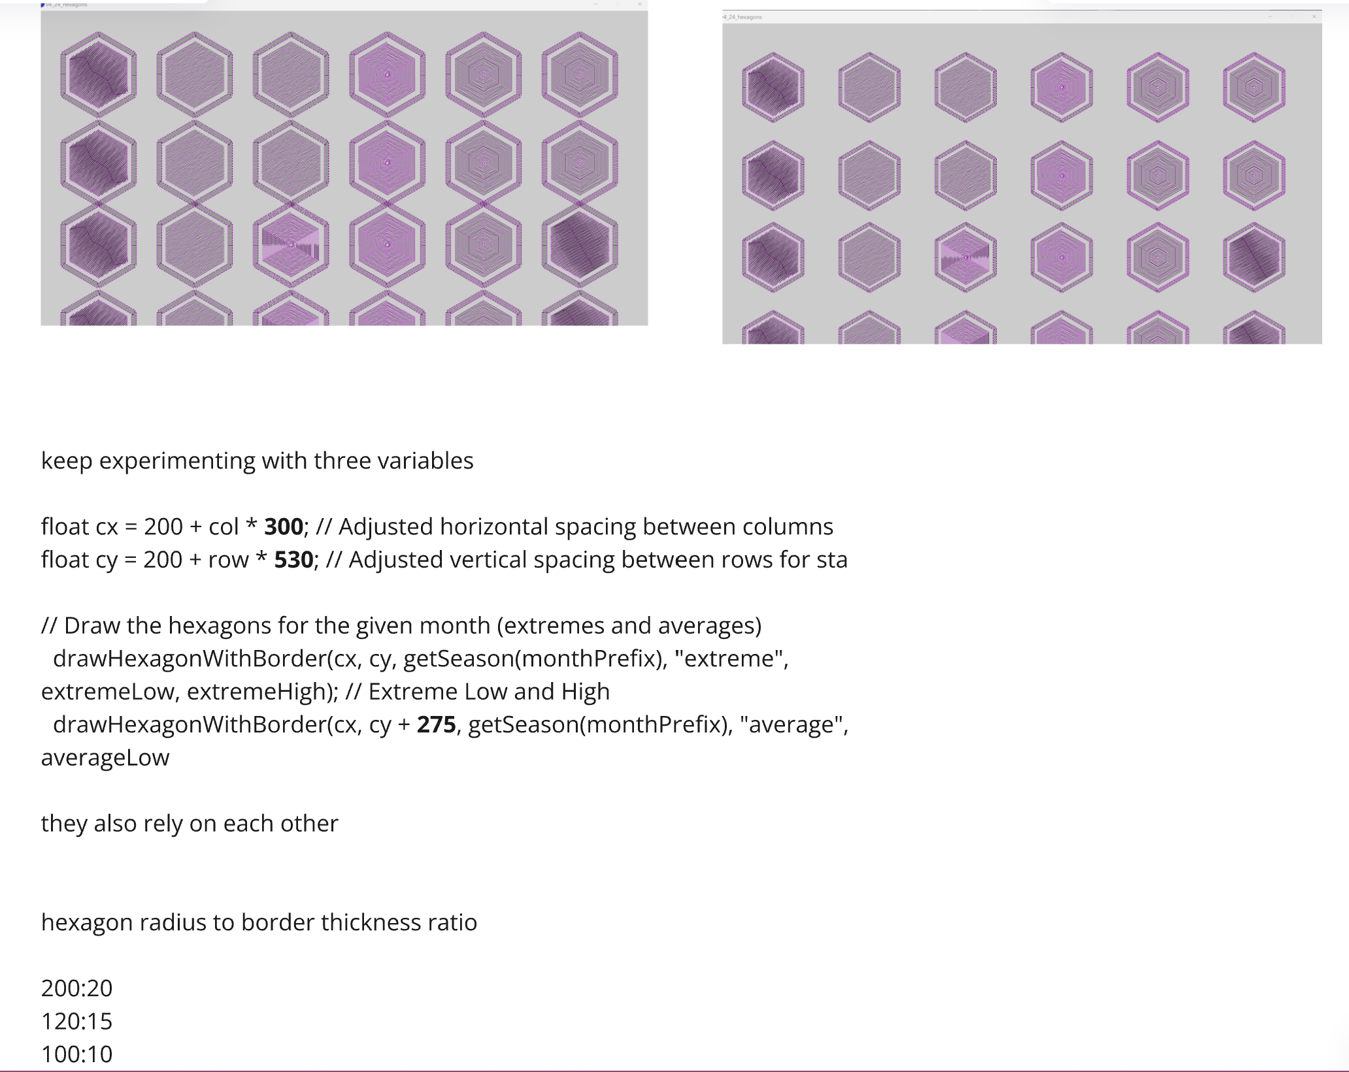

**Appendix F**

